**Fundamentals of Materials Processing (Part–1)**

**Professor Shashank Shekhar**

**Department of Materials Science and Engineering**

**Indian Institute of Technology, Kanpur**

**Lecture Number 12**

**Heat Flow (Effect of Superheat)**

**Keywords:** superheat, heat of fusion, temperature profile, finite element method, semi-infinite mold, matlab, chilled mold condition

Okay so we get back to our problem of superheat. Like I said earlier in the previous class that, for simplification purpose, we were assuming that temperature of the liquid or the liquid metal that you pour in is always at melting point; but that is not the case. There will always be some amount of or you want it to be a little higher than the melting point, because then the fluidity increases. If you are very close to the melting point, the fluidity is very poor. So now, how will the things change? We have always talked about the temperature profile with respect to assuming that the liquid temperature is constant.

(Refer Slide Time: 05:04)

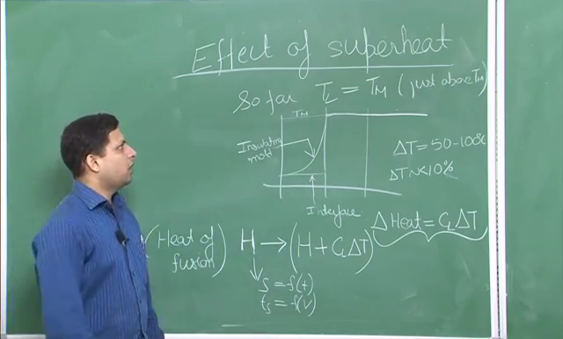

So if somewhere say the temperature was like this, and solid was like this, or it was something like this, in the two condition; this is the insulating mold, and later on we will see other conditions. These are two different conditions, but what was common in all these was that, solid will of course never go beyond TM, but the liquid is usually higher than TM. But then how much higher that is the question. The answer is it is usually of the order of 50 to 100 oC.

Now if we look at the temperature in Kelvin that is less than 10 % in terms of absolute temperature, the temperature delta T is approximately 10 % less than 10 % actually. So the temperature that we are talking about, the increase in the temperature, the liquid is not a very large quantity to look at the temperature profile, or to change the temperature profile by a much different value. But what will be different is that because there is a temperature rise, or the temperature is higher, and the liquid quantity may be very high; so, because of the specific heat of the material, when the liquid cools down, there will also be some amount of heat being generated or being given out because of that.

So what is that amount of heat? So that will be equal to, since we are talking about liquid, so CL∆T. Now this amount of heat is additional, and wherever we have used the term wherever we have talked in terms of heat energy, over there, we can make corrections by adding this term, because this is the only thing that is changing in a major way, otherwise, you see that the total temperature drop is less than 10 %; but even that 10 % temperature drop can lead to very large amount of change in the heat energy.

So what we usually do is, what was the place that we actually looked at the heat, or the total amount of energy, and that was heat of fusion H. So this heat of fusion H can now be changed to H + CL∆T. Now, once wherever we had that those values, if we replace those values by   
H + CL∆T, we will be able to take into account the effect of superheat. Since the liquid is at higher temperature, it will only change the total amount of heat and because of that, the solidification rate may be a little different and time required for total solidification may be a little different. And remember, the temperature profile equation does not have the H value, which means it will not get changed.